Reference Websites –
https://angpacmin.com/products/mill-scale/
https://iresources.co.in/mill-scale.html

Mill scale is the flaky surface layer formed on hot-rolled steel during manufacturing.

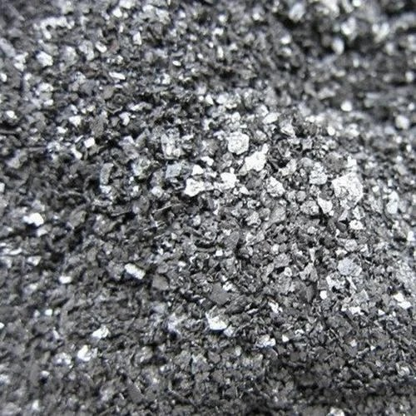

Mill scale is a flaky surface layer of iron oxides that forms on the surface of steel during the hot rolling process. When steel is heated and rolled in a mill, the high temperature causes the iron in the steel to react with oxygen in the air, producing a layer of oxides . This layer is tightly bound to the surface but can flake off during handling.
Mill Scale kya hota hai (thoda detail me)
>Jab steel ko high temperature (1000°C ke aas paas) pe heat karke roll karte hain (hot rolling),

us time steel surface pe oxygen react karta hai
Is reaction se banti hai:
Iron oxide layer (FeO, Fe₃O₄, Fe₂O₃)
Ye hi layer mill scale hoti ha

Key points about mill scale:

Appearance: Dark grey to black, flaky, and hard.

Formation: Occurs naturally during hot rolling of steel.

Uses:
recycled in steelmaking by remelting.
Can be used in powdered form for coatings, pigments

Grades of mill scales

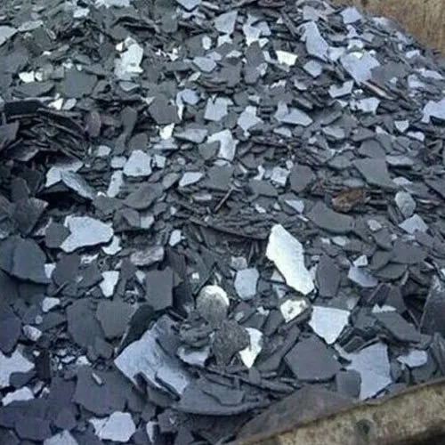
1. High-grade mill scale

Iron content: ~70–72% Fe
Impurities: Very low (like silica, sulfur, and carbon)
Use: Steelmaking powder coatings, pigments

2. Medium-grade mill scale
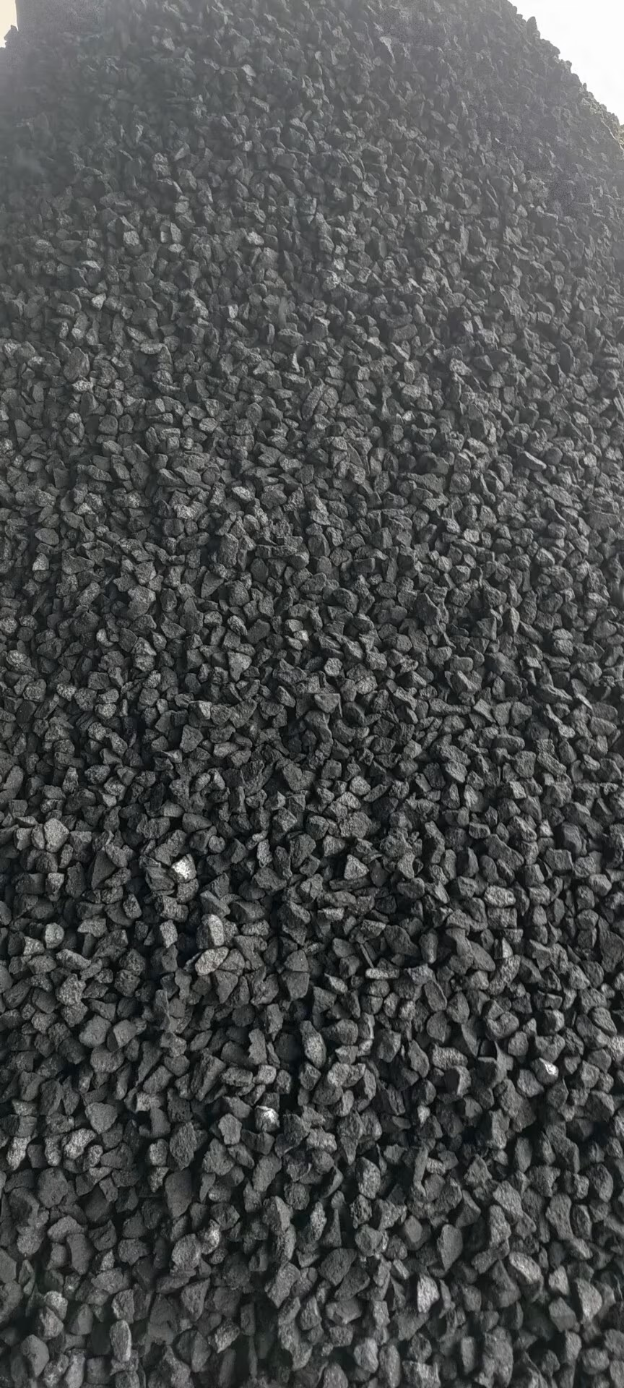
Iron content: ~65–70% Fe
Impurities: Moderate
Use: Scrap blending in steel production, some chemical processes
( Medium grade mill scale ka look thoda mixed hota hai:
Process:
Scrap steel + medium-grade mill scale → melted in furnace → new steel

Colour: black + grey mix (pure shiny black nahi hota)
Size: uneven particles (powder + chhote chips mix)
Texture: thoda dusty + thoda flaky )

3. Low-grade mill scale
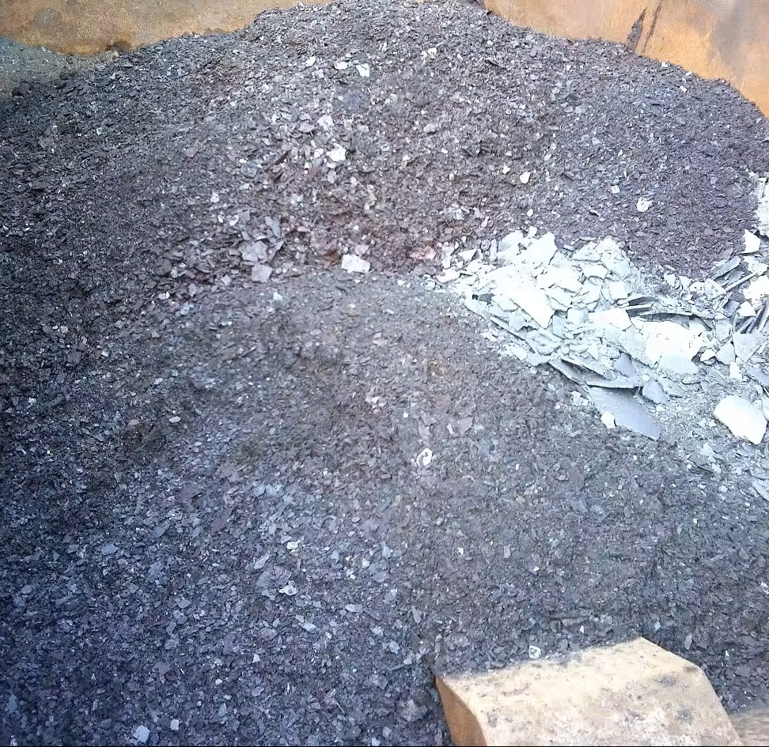
Iron content: <65% Fe
Impurities: Higher levels of sulfur, silica, or other metals

Use: Mainly in cement, refractory materials, or low-quality iron products
Refractory & low-quality industries purity doesn't matter
Cement ko jada majboot krne ke liye use hota hai or iski costing bhi km hoti hai
Iska price sabse kam hota hai

Ye low grade kyu hai?
Kyuki:
- Fe content kam hota hai (< 65%)
- Zyada contamination hoti hai (soil, rust, moisture)
- Research ke hisaab se mill scale generally powder/flakes form me hota hai aur easily break ho jata hai, isliye ground pe girke mix ho jata ha

Practical Difficulties encountered in procuring particular grade of Mill scale -
Mill Scale is a by-product generated during the hot rolling and processing of steel. It is often considered a waste material by many steel and rolling mills, but It has high value in the market due to its right iron content. The demand for mill scale is always high in industries like cement, sinter plant, and metal recovery. Most factories do not provide samples or detailed specifications because it is treated as a secondary material and is usually sold in bulk. Due to its high demand and limited availability, buyer who purchase quickly are able to secure the material, often without sampling, as the stock gets sold out very fast. Even though it is treated as waste at the source, it remains an important and widely used raw material in various industries.
Suppose a rolling mill has 150 MT of mill scale available, they will ask for price quote from different traders/Buyers and who ever quotes Rs 100 or Rs 200 higher gets the sale order. Foreign Buyer require particular grade like ( fe > 68% etc) but factories where its produced never tests it. And if as trader we request samples and even gets it it takes many days , by that time stock is sold out. And other factory has different grade of material and there also similar problem is faced.
So solution is be Roman in Rome and Buyers should understand that they need to act fast to secure supply without going into intricacies of test report etc.

Mill Scale Uses in Industries:

Steel Industry
Mill scale is recycled in steel making.
It is used as raw material to make new steel.

Paint and Pigment Industry
Contains iron oxide which gives red, black, or brown color.
Used in paints, inks, and ceramics.

Powder Coating Industry
Ground into powder and used in protective coatings on metals.

Cement and Refractory Industry
Low-grade mill scale is added to cement or bricks to increase strength.

Chemical Industry
Used to make ferrous compounds, like ferrous sulfate for fertilizers or water treatment.

Major places in India for Mill Scale:

Jharkhand – (Tata Steel area), Bokaro
Chhattisgarh – (Bhilai Steel Plant)
Maharashtra – (steel rolling mills)
Odisha – (Rourkela Steel Plant)
Karnataka – (steel plants & mini mills) Madhya Pradesh – (industrial zones with rolling mills)
Why is mill scale easily available in India?

1. High steel production

India is one of the top steel-producing countries.

Companies like Tata Steel, JSW Steel, and SAIL produce huge amounts of steel

More steel production = more mill scale generation

2. Large number of small rolling mills

India has thousands of small and medium rolling mills

These mills often have:
Basic setups
Less advanced cleaning systems

So, more mill scale falls and gets collected easily

3. Strong recycling market

In India, industrial waste is rarely wasted.

Mill scale is sold to:
Steel plants
Cement plants
Traders

Everything gets reused → high availability in the market

4. Low Labor cost
Manual collection is affordable
Even small quantities are gathered and sold

This increases overall supply

5. Export demand

India also exports mill scale to other countries (like Bangladesh, China)

So collection + trading is very active

> Who are the buyers of mill scale?

1. Steel Plants / Re-rolling Mills

>Biggest buyers

They reuse mill scale to recover iron
Includes:
Induction furnace units

Secondary steel plants

Regular and consistent buyers

2. Pigment Manufacturers
Convert mill scale into iron oxide pigments (black/red)
Used in:
Paints
Coatings
Tiles & construction colors

They prefer clean and fine (powdered) material

3. Chemical Companies

Use it to produce:
Ferrous sulphate (Water treatment (Ganda pani saaf karne ke liye)
Ferric sulphate

> Why Choose Us for Mill Scale Supply?
We are a trusted supplier of mill scale with a strong presence in the Indian steel industry. Our company has built long-term and reliable relationships with multiple rolling mills and industrial units, allowing us to ensure a continuous and stable supply of material.
With direct sourcing from manufacturers, we are able to provide:
- Consistent quality mill scale
- Competitive pricing
- Reliable monthly supply in bulk quantities
- Quick response and flexible delivery
Our well-established network enables us to fulfill both small and large volume requirements without delays. We understand the importance of consistency and reliability in your operations, and we are committed to delivering materials that meet your expectations.
Whether you are looking for a long-term supply partner or regular monthly shipments, we are fully equipped to support your business with dependable service and strong supply capabilities.
Why Buy From Us
We are an aggregator of mill scale and we collect material from different steel and rolling mill factories. Because of this, we are able to arrange bulk quantity as per requirement. We also take care of the complete logistics, so the delivery process becomes smooth and easy for the buyer. Our payment terms are flexible, which makes it convenient to do business with us. Overall, we try to provide a reliable and hassle-free supply of material.
Why Rolling Mills and Foreign Buyers Buy From Us
Rolling mills and foreign buyers prefer to work with us because we are able to arrange consistent supply from multiple sources. We understand the quality requirements and try to provide suitable material as per need. Since we deal with different factories, we can manage bulk quantity and regular supply.
For foreign buyers, we also assist in handling logistics and coordination, which makes the process easier and more reliable. Our flexible payment terms and quick response help in building long-term business relationships. We focus on smooth communication, timely delivery and dependable service, which makes us a preferred partner

